Week | Assignment | Using  Kit # | Forms due | Reports  due
1 | - | - | - | -
2 | 1B | 1 | C14, C16, C18, C20 | -
3 | 2A | 2 | C16, C18, C20, C25, C27, C29 | R1, R2
4 | 2B | 3 | C16, C18, C20, C25, C27, C29 | R3
5 | 3B | 4 | C16, C18, C20, C27, C29, C34, C37, C39 | -

Physical & Logical LOC Results

Program 1B
org.greg.drexel.b1.Main.java
- Physical LOC: 109
- Logical LOC: 32

org.greg.drexel.b1.gui.MainFrame.java
- Physical LOC: 296
- Logical LOC: 90

org.greg.drexel.b1.types.FileModeType.java
- Physical LOC: 32
- Logical LOC: 10

org.greg.drexel.b1.io.MyFileReader.java
- Physical LOC: 65
- Logical LOC: 13

org.greg.drexel.b1.io.MyFileWriter.java
- Physical LOC: 64
- Logical LOC: 12

Program 2A
org.greg.drexel.a2.loc.CountingStandard.java (Added from 1B)
- Physical LOC: 109
- Logical LOC: 33 (All 33 LOC added)

org.greg.drexel.a2.loc.LOCCounter.java (Added from 1B)
- Physical LOC: 87
- Logical LOC: 20 (All 20 LOC added)

org.greg.drexel.b1.Main.java (Modified from 1B)
- Physical LOC: 108
- Logical LOC: 41 (1B: 32, so 41-32 = 9 LOC added)

org.greg.drexel.b1.gui.MainFrame.java (Modified from 1B)
- Physical LOC: 174
- Logical LOC: 55 (1B: 90, so 90-55 = 35 LOC deleted)

org.greg.drexel.b1.io.MyFileReader.java (Untouched from 1B)
- Physical LOC: 65
- Logical LOC: 13 (Same LOC from 1B, untouched code)

org.greg.drexel.b1.io.MyFileWriter.java (Modified from 1B)
- Physical LOC: 64
- Logical LOC: 12 (Same LOC from 1B, only modified LOC)

Note: Completely removed org.greg.drexel.b1.types.FileModeType.java from 1B (10 LOC deleted)

Program 2B
org.greg.drexel.b1.Main.java (Modified from 1B)
- Physical LOC: 147
- Logical LOC: 46 (1B: 32, so 46-32 = 14 LOC added)

org.greg.drexel.b1.gui.MainFrame.java (Modified from 1B)
- Physical LOC: 478
- Logical LOC: 148 (1B: 90, so 148-90 = 58 LOC added)

org.greg.drexel.b1.io.MyFileReader.java (Untouched from 1B)
- Physical LOC: 65
- Logical LOC: 13 (Same LOC from 1B, untouched code)

org.greg.drexel.b1.io.MyFileWriter.java (Modified from 1B)
- Physical LOC: 64
- Logical LOC: 11 (1B: 12, so 12-11 = 1 LOC deleted)

org.greg.drexel.b1.types.FileModeType.java
- Physical LOC: 33
- Logical LOC: 11 (1B: 12, 1 LOC added)

org.greg.drexel.b1.types.FileModifyType.java (New in 2B)
- Physical LOC: 35
- Logical LOC: 13 (All 13 lines added, new class)

Program 3B
Because the user interface was designed with buttons, there was no additional work needed for "1. The user enters an improper mode selection". Even for the modes of Accept, Accept All, Insert, Delete, and Replace - all of these modes are received by button selection, which is the same force constraint placed on the user which will not allow improper input.

For "2. The user enters an improper data character". The user interface needed to be slightly modified. Because there was already some minimal error checking, the displayWarning() method was modified to support the user select of either "Ok" to proceed after data input error or "Terminate Program" to exit the program per the program spec.

This means that program 3B did not have much code required to complete.

org.greg.drexel.b1.Main.java (Untouched from 2B)
- Physical LOC: 147
- Logical LOC: 46

org.greg.drexel.b1.gui.MainFrame.java (Modified from 2B)
- Physical LOC: 484
- Logical LOC: 151 (2B: 148, so 151-148 = 3 LOC added)

org.greg.drexel.b1.io.MyFileReader.java (Untouched from 2B)
- Physical LOC: 65
- Logical LOC: 13

org.greg.drexel.b1.io.MyFileWriter.java (Untouched from 2B)
- Physical LOC: 64
- Logical LOC: 11

org.greg.drexel.b1.types.FileModeType.java (Untouched from 2B)
- Physical LOC: 33
- Logical LOC: 11

org.greg.drexel.b1.types.FileModifyType.java (Untouched from 2B)
- Physical LOC: 35
- Logical LOC: 13

Totals
Program 1B
- Physical LOC: 626
- Logical LOC: 157
Program 2A
- Physical LOC: 607
- Logical LOC: 174
Program 2B
- Physical LOC: 822
- Logical LOC: 242
Program 3B
- Physical LOC: 828
- Logical LOC: 245

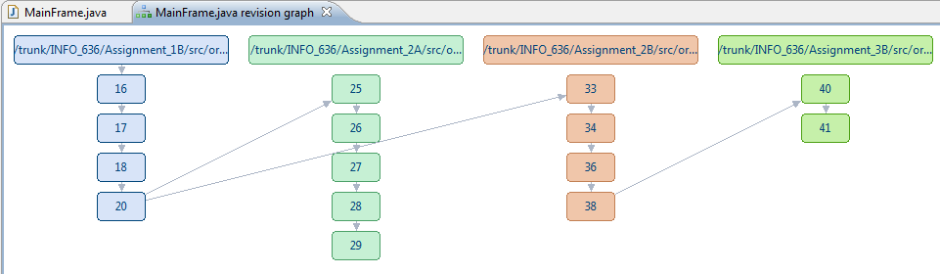
Note: Assignment 2B was SVN merged into Assignment 3B.
Program 3B Screenshots
Screenshots during testing

We will test the functionality for the Read, Write and Modify modes. Because Program 3B only aims to modify a little portion of the number validation code, we will specifically validate this.

Validate mode selection
- User cannot select any mode other than the ones presented because of forcing function within Java user interface.

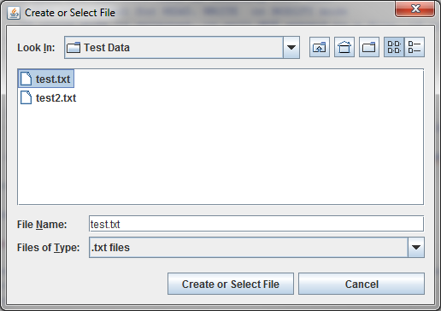
Figure 1. Select test.txt for Reading

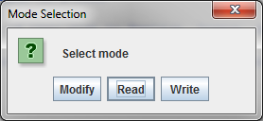
Figure 2. User can only select from three modes

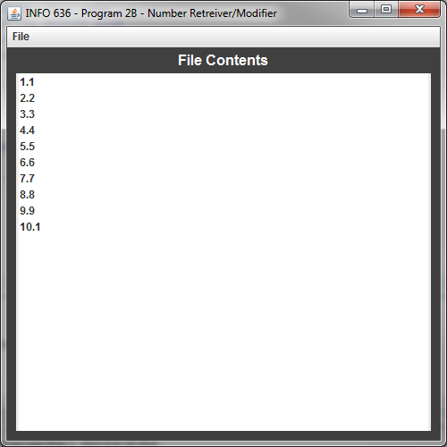
Figure 3. Because Read was selected, the file is displayed

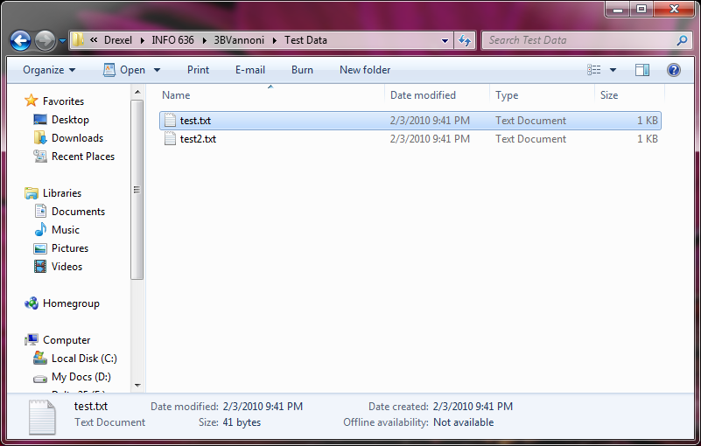
Figure 4. Physical file location displayed

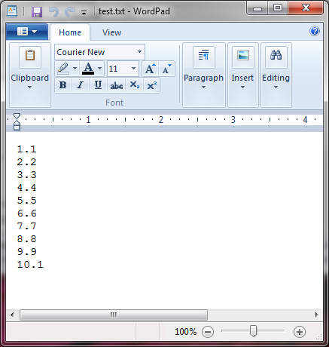
Figure 5. Physical file contents as shown with Wordpad in Windows

Write mode validation
- User is unable to make invalid mode selection.
- Number input validation (modified from 2B) comes into effect.

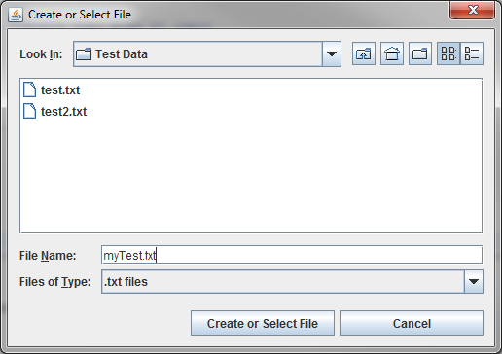
Figure 6. Declare new file myTest.txt for writing

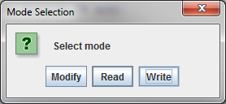
Figure 7. User must select one of the three modes, in this case Write mode is selected

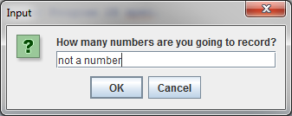
Figure 8. User's input is validate to be a integer number, this is not a valid input

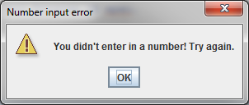
Figure 9. The error message from Assignment 2B

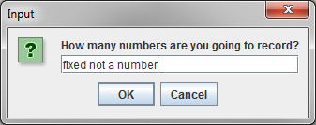
Figure 10. User must enter valid integer number, this is not a valid input

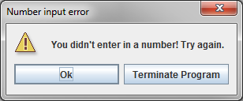
Figure 11. The updated error message to conform Program 3B specifications

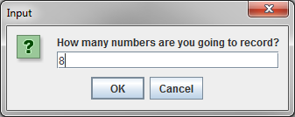
Figure 12. An example of valid integer input

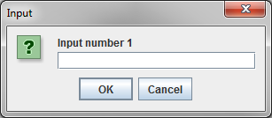
Figure 13. The program asks for each input
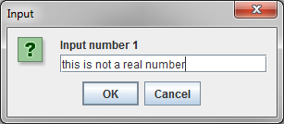
Figure 14. The system will validate the input is a real number, this is not a valid input

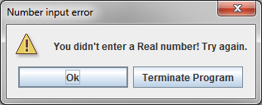
Figure 15. The system was updated to conform to the program 3B specification when warning the user

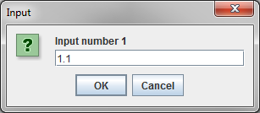
Figure 16. User enters valid input (a real number)

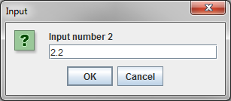
Figure 17. User enters another valid input

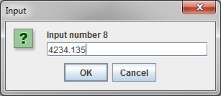
Figure 18. A little later, the user enters in the last valid input
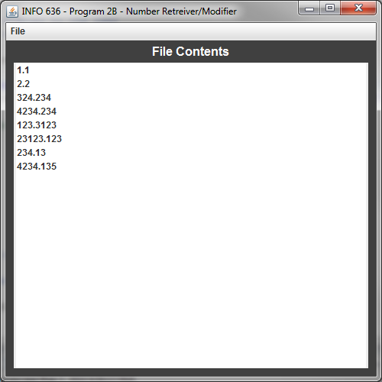
Figure 19. The complete user input is displayed

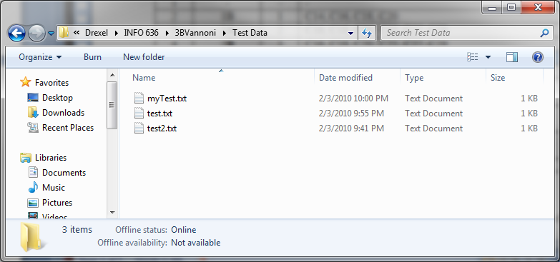
Figure 20. The new file "myTest.txt" now exists
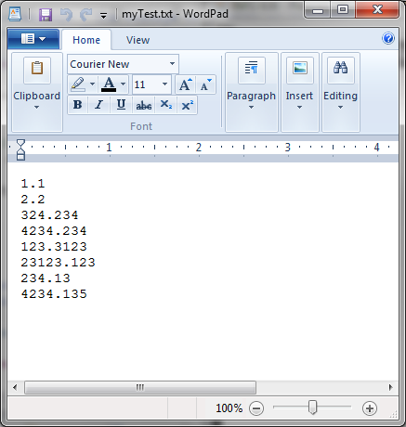
Figure 21. The file myTest.txt displayed in WordPad

Modify mode validation
- User is still forced to use the correct modes (same forcing function using buttons)
- The "Insert" mode does the updated number validation with warning dialog box if the input is not valid.
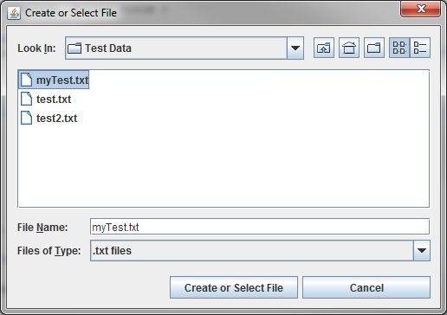
Figure 22. The myTest.txt file is selected

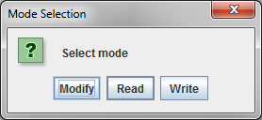
Figure 23. The Modify option is selected

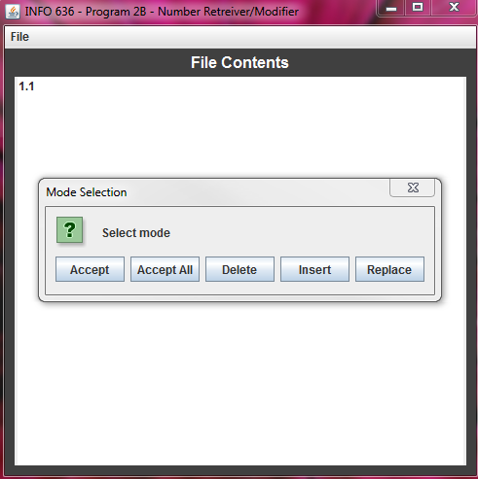
Figure 24. Same mode selection from 2B is displayed

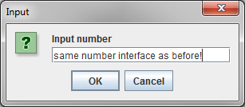
Figure 25. Insert mode selected with invalid input. This uses the same code as the previous real number validation

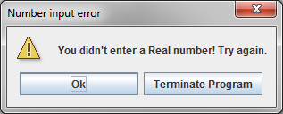
Figure 26. The updated warning message for program 3B is still displayed

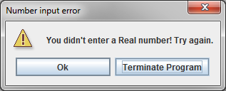
Figure 27. User can select "Terminate Program" to exit the application or "Ok" to be prompted for input again
Table C16: Time Recording Log

Student |  | Greg Vannoni |  |  |  |  | Date | 2/3/10
Instructor |  | Glenn Booker |  |  |  |  | Program # | 3B
Date | Start | Stop | Interruption  Time | Delta  Time | Phase | Comments
2/3 | 8:30p | 8:50p | 5 | 15 | PLANNING | Made some coffee! Tried to understand what Program 3B needs to do (which isn't much from Program 2B!) and read a little of the narrative notes for this week
2/3 | 8:51p | 9:00p | 0 | 9 | DESIGN | Selected the target for all of the Program 3B changes, the displayWarning() method, made sure that nothing else needs to change.
2/3 | 9:01p | 9:15p | 0 | 14 | CODE | Added small code modification to support Program 3B
2/3 | 9:16p | 9:30p | 0 | 14 | PM | Attempted to figure out what all these new forms mean before I go on with testing
2/3 | 9:31p | 9:32p | 0 | 1 | COMPILE
2/3 | 9:40p | 10:00p | 0 | 20 | TEST | Tested the updated program with all different modes took screenshots
2/3 | 10:01p | 11:00p | 5 | 59 | PM | Filling out all of these darn forms!

Table C18 Defect Recording Log
Defect Types
10 Documentation 60 Checking
20 Syntax 70 Data
30 Build, Package 80 Function
40 Assignment 90 System
50 Interface 100 Environment
Student |  |  |  | Greg Vannoni |  |  |  |  |  |  |  | Date |  | 1/25/10
Instructor |  |  |  | Glenn Booker |  |  |  |  |  |  |  | Program # |  | 2B
Date |  | Number |  |  |  | Type |  | Inject |  | Remove |  |  | Fix Time |  | Fix Defect
2/3 |  | 1 |  |  |  | 80 |  | design |  | test |  |  | 1
Description: |  |  | Forgot to remove previous JOptionPane dialog box before I added the new dialog box
so I was getting two different dialog boxes, the old one, followed by the new one. Removed the old one
by just removing one line.
Date |  | Number |  |  |  | Type |  | Inject |  | Remove |  |  | Fix Time |  | Fix Defect
Description:
Date |  | Number |  |  |  | Type |  | Inject |  | Remove |  |  | Fix Time |  | Fix Defect
Description:
Date |  | Number |  |  |  | Type |  | Inject |  | Remove |  |  | Fix Time |  | Fix Defect
Description:
Date |  | Number |  |  |  | Type |  | Inject |  | Remove |  |  | Fix Time |  | Fix Defect
Description:
Date |  | Number |  |  |  | Type |  | Inject |  | Remove |  |  | Fix Time |  | Fix Defect
Description:
Date |  | Number |  |  |  | Type |  | Inject |  | Remove |  |  | Fix Time |  | Fix Defect
Description:

Table C27 Process Improvement Proposal (PIP)

Student | Greg Vannoni |  | Date | 2/3/10
Instructor | Glenn Booker |  | Program # | 3B
Process | PSP1 | Elements

PIP Number
 |  | Problem Description:
 |  | None for this time, this was a very small program change
PROPOSAL
PIP # |  | Proposal Description
Notes and Comments:

Table C34 PSP1 Project Plan Summary

Student | Greg Vannoni | Date | 2/3/10
Program |  | Program # | 3B
Instructor | Glenn Booker | Language | Java

Summary | Plan |  |  |  | Actual |  |  |  | To Date
LOC/Hour | 5 |  |  |  | 3LOC/14m = 0.214 * 60 = 12.86 |  |  |  | 12.86
Program Size (LOC): | Plan |  |  |  | Actual |  |  |  | To Date
Base(B) | 242 |  |  |  | 242
 | (Measured) |  |  |  | (Measured)
Deleted (D) | 1 |  |  |  | 0
 | (Estimated) |  |  |  | (Counted)
Modified (M) | 1 |  |  |  | 1
 | (Estimated) |  |  |  | (Counted)
Added (A) |  |  |  |  | 245-242+0-0=3
 | (N-M) |  |  |  | (T-B+D-R)
Reused (R) | 0 |  |  |  | 0 |  |  |  | 20
 | (Estimated) |  |  |  | (Counted)
Total New & Changed (N) | 5 |  |  |  | 3+1=4 |  |  |  | 193+4 = 197
 | (Estimated) |  |  |  | (A+M)
Total LOC (T) | 5+242-1-1+0=245 |  |  |  | 245 |  |  |  | 416+245=661
 | (N+B-M-D+R) |  |  |  | (Measured)
Total New Reused (Reusable) | 0 |  |  |  | 0 |  |  |  | 70
Time in Phase (min.) | Plan |  | Actual |  |  |  | To Date |  |  |  | To Date %
Planning | 10 |  | 15 |  |  |  | 50 |  |  |  | 3.89%
Design | 10 |  | 9 |  |  |  | 60 |  |  |  | 4.68%
Code | 10 |  | 14 |  |  |  | 554 |  |  |  | 43.18%
Compile | 1 |  | 1 |  |  |  | 8 |  |  |  | 0.62%
Test | 5 |  | 20 |  |  |  | 124 |  |  |  | 9.66%
Postmortem | 80 |  | 73 |  |  |  | 487 |  |  |  | 37.96%
Total | 116 |  | 132 |  |  |  | 1283 |  |  |  | 100%
Defects Injected |  |  | Actual |  |  |  | To Date |  |  |  | To Date %
Planning |  |  | 0 |  |  |  | 5 |  |  |  | 38.46%
Design |  |  | 1 |  |  |  | 3 |  |  |  | 23.08%
Code |  |  | 0 |  |  |  | 5 |  |  |  | 38.46%
Compile |  |  | 0 |  |  |  | 0 |  |  |  | 0
Test |  |  | 0 |  |  |  | 0 |  |  |  | 0
Total Development |  |  | 1 |  |  |  | 13 |  |  |  | 100%
Defects Removed |  |  | Actual |  |  |  | To Date |  |  |  | To Date %
Planning |  |  | 0 |  |  |  | 0 |  |  |  | 0
Design |  |  | 0 |  |  |  | 1 |  |  |  | 7.69%
Code |  |  | 0 |  |  |  | 4 |  |  |  | 30.77%
Compile |  |  | 0 |  |  |  | 0 |  |  |  | 0
Test |  |  | 1 |  |  |  | 8 |  |  |  | 61.54%
Total Development |  |  | 1 |  |  |  | 13 |  |  |  | 100%
After Development |  |  | 0 |  |  |  | 0

Table C37 Test Report Template

Student | Greg Vannoni | Date | 2/3/10
Instructor | Glenn Booker | Program # | 3B

Test Name/Number | Read functionality
Test Objective | Determine if there has been regression to Read functionality
Test Description | This function has not changed since Program 2B, ensure
 | ensure that the user can still read the file like in 2B.
Test Conditions | 1. File must already exist with real numbers
Expected Results | 1. File selected and displayed in JList just like in
 | Program 2B
Actual Results | Success. Program displayed file just like Program 2B.
Test Name/Number | Write functionality
Test Objective | Ensure write functionality from 2B still exists and that new warning message is displayed
Test Description | 1. Ensure that write functionality has not regressed since 2B
 | 2. Ensure that new warning dialog box is displayed
 | when a number is not properly input to system.
Test Conditions | None
Expected Results | 1. File should be written to selected directory just like 2B
 | 2. If invalid input is given, a dialog box should appear that allows the user to continue (retry) or exit the application.
Actual Results | Success. No regression to write capability, dialog box with
 | "Ok" and "Terminate Application" are displayed when
 | invalid number (integer when asked for quantity of
 | numbers and double/real number when asked for number
 | input.
Test Name/Number | Modify functionality
Test Objective | Ensure that there has been no regression in modify functionality and that the user can only select from the options in program 2B.
Test Description | 1. Validate that no functionality has changed since 2B
 | 2. Select the "Insert" button after the "Modify" mode is selected and validate that invalid number input (for real numbers) has the Program 3B warning message to the user.
Test Conditions | User must select "Modify" mode to be presented with
 | modify functionality
Expected Results | 1. If the user selects the "Insert" mode, and inserts a non-real number, a warning dialog should be displayed.
 | 2. All existing 2B functionality for Accept, Accept All, Replace and Delete should exist unmodified.
Actual Results | Successful, all tests passed.

Table C39 Size Estimating Template
SEE SPREADSHEET FOR MORE CALCULATIONS

Student | Greg Vannoni | Date | 2/4/10
Instructor | Glenn Booker | Program # | 3B

BASE PROGRAM |  |  |  |  |  |  |  |  |  |  |  |  |  |  | ESTIMATE |  |  |  |  |  |  |  | ACTUAL
BASE SIZE (B) => => => => => => => => => => |  |  |  |  |  |  |  |  |  |  |  |  |  |  | 242 |  |  |  |  |  |  |  | 242
LOC DELETED (D) => => => => => => => => => |  |  |  |  |  |  |  |  |  |  |  |  |  |  | 1 |  |  |  |  |  |  |  | 0
LOC MODIFIED (M) => => => => => => => => => |  |  |  |  |  |  |  |  |  |  |  |  |  |  | 1 |  |  |  |  |  |  |  | 1
OBJECT LOC
BASE ADDITIONS: |  |  | TYPE 1 |  |  |  | METHODS |  |  |  | REL. SIZE |  |  |  |  |  | LOC |  |  |  |  |  |  |  | LOC
Add input for displayWarning() |  | L |  |  |  |  |  | 1 |  |  |  | VS |  |  |  |  |  |  | 2 |  |  |  |  |  | 2
TOTAL BASE ADDITIONS (BA) => => => => => =>
NEW OBJECTS: |  |  | TYPE |  |  |  | METHODS |  |  |  | REL. SIZE |  |  |  |  |  | LOC (NewReuse*)
Options Array |  | S |  |  |  |  |  | 1 |  |  |  | VS |  |  |  |  |  |  | 1 |  |  |  |  |  | 1
Dialog box |  | I |  |  |  |  |  | 1 |  |  |  | VS |  |  |  |  |  |  | 1* |  |  |  |  |  | 1
TOTAL NEW OBJECTS (NO) => => => => => => =>
REUSED OBJECTS
Dialog box | I | 1 |  |  |  |  |  |  |  |  |  | VS |  |  |  |  |  |  | 1 |  |  |  |  |  | 1
REUSED TOTAL (R) => => => => => => => => =>
 |  |  |  |  |  |  |  |  |  |  |  |  |  |  |  |  |  |  | SIZE |  |  |  |  |  | TIME
Estimated Object LOC (E): E = BA + NO + M
Regression Parameter: 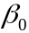 (size and time) |  |  |  |  |  |  |  |  |  |  |  |  |  |  |  |  |  |  | 23.60
Regression Parameter: (size and time) |  |  |  |  |  |  |  |  |  |  |  |  |  |  |  |  |  |  | 0.7151
Estimated New and Changed LOC (N): N = + * E |  |  |  |  |  |  |  |  |  |  |  |  |  |  |  |  |  |  | 27.1847
Estimated Total LOC: T = N + B - D - M + R |  |  |  |  |  |  |  |  |  |  |  |  |  |  |  |  |  |  | 246
Estimated Total New Reused (sum of * LOC): |  |  |  |  |  |  |  |  |  |  |  |  |  |  |  |  |  |  | 2
Estimated Total Development Time Time = + * E |  |  |  |  |  |  |  |  |  |  |  |  |  |  |  |  |  |  | 57.993
Prediction Range: Range
Upper Prediction Interval: UPI = N + Range |  |  |  |  |  |  |  |  |  |  |  |  |  |  |  |  |  |  | 85.18
Lower Prediction Interval: LPI = N - Range |  |  |  |  |  |  |  |  |  |  |  |  |  |  |  |  |  |  | -30.81
Prediction Interval Percent: |  |  |  |  |  |  |  |  |  |  |  |  |  |  |  |  |  |  | 70%
1 L-Logic, I-I/O, C-Calculation, T-Text, D-Data, S-Set-up

